The investigation of the potential of investing in the Google or Apple Corporations

Written by Class2-Group 24: Chen Jiawei
Chen Yichang
Fang Xiao
ShengSiyuan Zhang Kun 张昆

Finished Date Sep24th 2011

Contents

List of Figures………………………………………………3

Executive Summary……………………………………….4

Methods……………………………………………………..5

Introduction………………………………………………….5

Main Body……………………………………………………6

Conclusion…………………………………………………..12

Recommendations………………………………………….13

References…………………………………………………..14

List Of Figure

Total Revenue of Apple and Google…………………………………………………6

Net Income of Apple and Google…………………………………………………….6

Tablets Market Reach…………………………………………………………………….8

Market Reach of Two Important Market…………………………………………..8

Value of top brands, in billions of dollars………………………………………….10

Apple and Google online discussion level………………………………………….10

Apple’s advertising budgets…………………………………………………………….12

Executive summary
In this report, we will show the following key points:
1. Finance
Comparing Google and Apple’s total revenue, net income, total assets, and market value, we will make a conclusion that Apple is better than apple in all of these things.
2. Marketing Reach
Showing the market share of Apple and Google on the Tablet PC and
Mobile operation system.
3. Products and services
Apple has many electronic products and all these products sell very well. Google main products are software .One of Google main software Android is operation system like apple’s system, but in function and quality are worse than apple. Apple service has good reputation because Apple has the strict after-sales service system. 4. Grand Image
Apple’ brand are more valuable than Google. And It’s products attract more attention than Google. We do think the future of apple’s brand is bright.
5. Corporate Social Responsibility And Marketing Way
Google has been firmly committed to addressing the global challenges of climate change, education and poverty.
Apple requests its supplier return the fee for accepting excessive totaled us $3.4 million since 2008.
Google and the Chinese government's ideas are not unified, while Apple pays more and more attention to the Chinese market.

Methods
Firstly, we make sure the 6 parts including Finance, Market Reach, Products & Service, Grand Image etc. And we search Google and Apple online in terms of these things.
All of the information are found in the Internet, I will list them in the references part.

Introduction
In order to conduct CIC to choose one of Apple and Google to invest in, we did this report.
During the main body, firstly we will show you the financial situation of the two companies, and make an analysis of their finance.
Secondly we will show you some market information for you, and we will give our analysis, too.
Thirdly, we will make a brief introduction of Products & Service of the two companies, and give you our opinions.
Last, we’d like to show you Brand Image, Corporate Social Responsibility,and Marketing Way. We will also give some advice in this part.

The Main Body
- Finance

1.1 Profits
A company is worth the investment or not, its financial condition quality is the most important part. So I will list Apple and Google's financial report for analysis.
Total Revenue of Apple and Google
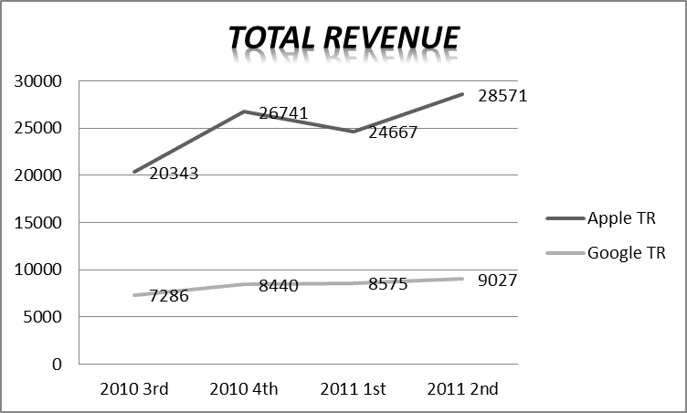
We can be seen from the graph above, in total income, though Apple has ups and downs, its rise significantly greater than Google. In general, its total revenue is two to three times of Google, this suggests that the scale and business efficiency of Apple are better than Google’s.
1.2Assets
Net Income of Apple and Google
Million dollars | Apple NI | Google NI
2010 3rd | 4308 | 2167
2010 4th | 6004 | 2543
2011 1st | 5987 | 1798
2011 2nd | 7308 | 2506

Apple in net profit growth ahead Google, except the first quarter of 2011, the other three quarters’ growth rate is close to 50%. And Google have almost no growth in the same period.
We can make a conclusion that Apple makes money faster than Google.

When comparing the total net assets, Apple and Google almost the same. But once we concentrating on market value in which play an important role in a company’s business development, Apple is far more than Google. So far (Step.14th.2011), Apple has the second highest market value, about $360 billion, and Google even can’t get into the top10.
1.3For now
Recently, apple officially announced the third quarter of this year's financial report. Until last month, apple sold 20.34 million mobile phones, 9.25 million tablets, increased by 183% compared with the same period last year and sold 3.95 million personal computers. Only in the third quarter of this year, apple earned $7.31 billion, increased 82% compared with last year.

Results showed that this quarter only iPhone brings revenues of $13.3 billion, close to half of the gross income. And iPhone 4 still occupy the whole smartphone market of nearly 50% of the profits. In addition, the iPad and Mac this quarter revenues earned $6 billion and $5.1 billion, and is also an important source of income for Apple.

Consider revenue and net profit growth rate, we see Apple is not only the biggest one, but also the fastest growing technology enterprise, the young Google although met with some difficulties, but still grows quickly.

Google claims that Google now has 39 billion dollars in cash, increased by 30% compared to the same period last year.

But these data on the apple front, immediately become overshadowed. Apple earnings show, end on June 30, 2011, the cash is $76.2 billion, and on July 27, the United States ministry of finance total operating cash balance was $73.77 billion. In other words, apple to some extent even better than the American government.

“What Amazing is, different with the United States government for the so-called ‘to borrow money kept in the debt crisis’, apple "zero liability" nearly none.
___________www.zol.com.cn who is the money maker? An Qi
All of these things showed apple’s great performance, Google is also good but not enough.
So we can make a conclusion that if we only consider about finance part, invest in Apple is better than invest in Google.

- Market Reach
Market Reach of Two Important Market
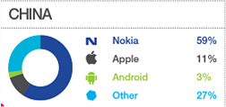
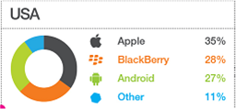
This picture tell us mobile operation system market share. I found two typical place of China and the United States. And from China can been seen in the table APPLE’S market share is 11%. and only 3% of ANDROID. From another America can be seen. APPLE’S market share is 35%. While ANDROID is 27%. We can easily come to APPLE’S mobile operation system is strong than ANDROID’S.
All in all, Apple's future development is very large, especially in the Tablet PC.
Tablet PC market has growth potential. Gartner predicts that by 2011, Tablet PC shipments by 2010 17 million to 70 million; 2015 Tablet PC shipments will reach 294 million.
Apple Tablet PC market has achieved quite remarkable leader. Therefore, even if Apple's market share is expected to be from 84% in 2010 down to 47% in 2015, but due to the lead edge of the record of the user base is expected in 2015, Apple iPad shipments will reach 138 million still . Meanwhile, the Tablet PC with Android system will be rapid growth in 2010, Android system, Tablet PC market share will reach 39%, shipments will reach 113 million. Future, iOS and Android are two systems, will become a "post-PC era" an important role in the field of mobile computing.

Products and services
In the past ,PC has a host computer and a monitor .mobile phone has many button. And people don’t know what is tablet PC. But a very big change has happened when apple manufacture first iMac, iPhone, iPad.
As we know Apple has many electronic products such as IMac, iPhone, iPod Nano, iPod touch and iPad .iMac is all-in-one computer .Steve jobs to "what 's not a computer" concept used in design iMac.
Ipad is tablet PC. IPad positioning between iPhone and MacBook . IPad only four buttons. It provide Internet surfing, send e-mails, play audio or video and watching eBook etc. They all has these characteristics: fashion appearance, powerful function adequate quality and sell very well or very quickly
Apple has their own operating system called Mac OS X and this system is leading global. All apple products are with this system. Furthermore apple has more than one hundred thousand applications.
Apple service has good reputation. If you want to get repair authorized, you must employ many people who through apple train and authentication, This authentication is very serious. According to the online survey at this point Google is lacking.
IPhone 5 will appear on the market, let’s wait and see.

4.Grand Image

- Apple’ brand are more valuable than Google.
I believe a piece of news coming from WPP’s Millard Brown unit has shocking the every person that Apple overtook Google to become the world’s most valuable brand in May 2011. We can get conclusion from table1-1 that Apple’s brand value climbed 84 percent to $153.3 billion in the past year and Google’s brand lost 2 percent to $111.5 billion. $41.8 billion may be a big different between them.
Value of top brands, in billions of dollars, May-2011(table1-1)
Rank |  | Brand |  | Value in $ million | Brand Value change  from 2010
1 |  | Apple |  | 153,285 | +84%
2 |  | Google |  | 111,498 | -2%

(2) Apple’s products attract more attention than Google.
Other more I get a set of statistics on CNET shows online discussion levels for Apple product dominate all other products and brands even Google. From table2-1 we can clear find people pay more attention to Apple’s product than Google’s. Apple products have taken on their own life very quickly.

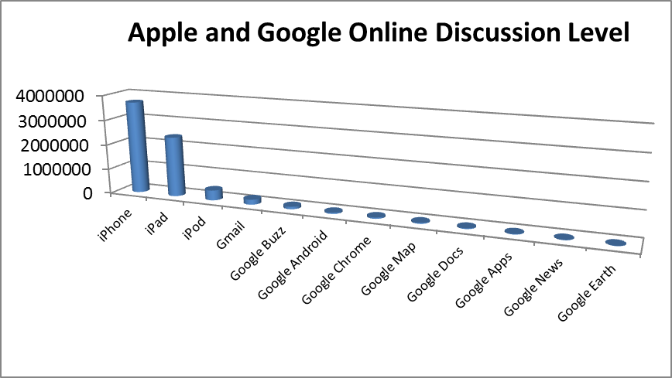
Table 2-1

(3) My own opinion about the brand image.

I think the brand image not only reflected in brand value, the important is what product brings us. Maybe it can take us a new experience or we can learn from the story of it.

Fascination Apple
The influence of a mobile phone cannot draw conclusion from a simple feature comparison of sales and market. But in many areas, the “first” can give us the most profound impression. The iPhone changed the people for the emergence of the mobile phone ever. Instead of monotony of boring before the iPhone became first mobile phone which has smooth and enjoyable operation. So although iPhone has various defects, people are more concerned about the iPhone bringing their own unique fashion sense, not the machine itself. That’s glamorous and deep-rooted brand image which any other product cannot bring us.

The Story of Apple
With Steve Jobs: A Biography has been published in November 21th 2011, people are more concern about Steve Jobs who found the Apple. The book describes his ups and downs of the life, underlined his persistent personality, show the pursuit of perfect and creative jobs and passion. We not only like the innovative product of Apple but also admire Jobs never giving up.

(4) The future of apple’ brand
Someone may be ask me that statistics just only state how strong the brand is recently and you don’t know how it’s likely to grow in the future. Brand image include expanding the market, dominating the market and profit ability. Innovation is the source of brand influence. Strong market positions, innovative products and satisfied services, from what has been discussed above it would be reasonable to believe that the brand of Apple will grow stronger in the future.

5. Corporate Social Responsibility, And Marketing Way.

Corporate Social Responsibility (CSR) is a company should creating profits and at the same time their must undertake the responsibility to employees, the consumers, the community and the environment.
Google has been firmly committed to addressing the global challenges of climate change, education and poverty.
And apple also can be the model in fulfill Corporate Social Responsibility. For example, Apple request its supplier return the fee for accepting excessive totaled us $3.4 million since 2008. And Apple interrupted cooperative relationship with three suppliers which serious violations. So, many enterprises should learn from apple, have the courage to take responsibility for their own supply corporate social responsibility.
Marketing way
Google is not famous for the marketing ability, the company believes search products are enough to excuse success tablet. So far, Google the major source of income for text search advertising. Meanwhile, Google is taking business diversification measures, with the ultimate goal of reducing to text search advertising revenue the dependence of the single. And they attract new customers by using Google Ad Words which can make your advertisement displayed in Google and they charge fees. And Google AdSense is use your web site obtains earnings.
Obviously, apple is successful in the products release.
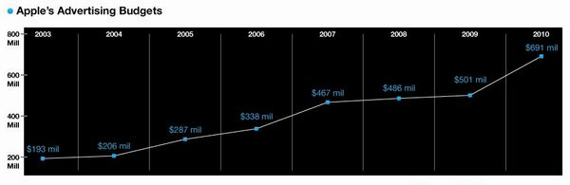 From 193 million dollars in 2003 to 691 million dollars in 2010, apple advertising budgets increased year by year. However, we can see the percentage of income by expenditure. Apple in the past 10 years advertising spending decrease, accounting for more than 5% in 2001 from fall to 1.06% in 2010.
They also set up a lot Apple store aims to improve the apple brand awareness. In 2009, every $8 dollars advertising spending will have $1 put into apple store .And Apple store also in order to make customers get better experience.
In a word, Apple is good at linkage with the influence of the different media, through media to realize mouth marketing, make the product gathered widely anticipated.
As we all know, Google search out of China. Because Google and the Chinese government's ideas are not unified. And Google announced that it and its users have been influenced by the Chinese government hacker attacks. So Google will lose a huge market.
But Apple readjusts marketing way to adapted to the Chinese market.
Now Apple pays more and more attention to the Chinese market. Apple begins to accelerate the speed of the stores in China, September, iPhone 4 will sale in the Chinese market, and there will be two stores opened in China. Apple says, apple stores amount will reach 25 in the end of 2012.

Conclusion

Recommendations
According to what we concluded above, I would like to give such suggestions:

1. When you choose a company to invest in , the most important part you should to consider is finance, and once you made a decisions you still need to care about the financial change of the company.

2. Apple market is more stable than Google, nothing can instead of iPhone or iPad but Google can be instead by Baidu etc. so choose apple is safer.

3. We suggest you invest in apple for a long time. it will bring you a great more profits, cause apple earn money very quick and never has too much debt.

4. Consider how the two companies treat the Chinese market, as a Chinese investigation Cooperation, and after you invest in one, you need to help the company communicate with the government.

